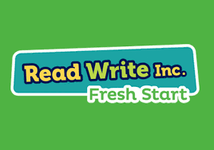
S1 & S2 Fresh Start

Read Write Inc. Fresh Start is a synthetics phonics programme to support pupils who have struggled to make progress with reading and writing skills. Identified pupils follow this programme within the Support for Learning Department three periods per week in S1 and two periods per week in S2.
The resource covers reading accuracy, fluency, comprehension, spelling and writing. A key part of the programme is the ‘speed sounds lessons’. Flash cards and speed sounds charts are used to teach letter sounds and graphemes. 33 module booklets and anthologies are used to deliver the programme. Each module builds on known sounds and words.
Built into the module booklets are spelling, vocabulary and grammar exercises. Pupils learn how to spell common words with common graphemes and suffixes, spell common words with unusual graphemes and how to write prepared sentences with correct spelling and punctuation.
Pupils also have access to IDL Literacy, a web based phonics programme which can be accessed from home to further reinforce their phonics learning.
Target sheets are completed and posted home at the end of the programme. Pre and post testing is completed using the Single Word Spelling Test, the Single Word Reading Test and the Suffolk Reading Comprehension Scale to measure the impact of the support.

For more detailed information, follow the link below:

https://assets.publishing.service.gov.uk/government/uploads/system/uploads/attachment_data/file/292482/read_write_inc_fresh_start___oup.pdf

